Hello everyone,

During this past year, when we have experienced a flood of uncertainty, turmoil, and emotional angst, it was not unusual to hear people, including me, say ‘what would Mister Rogers do in this situation,’ ‘how would he talk to our family about such a scary time.’

I was fortunate to have known Fred during his work at WQED. His powerful presence yet calming demeanor always inspired me to use my position at the station as a beacon towards empowering young people to succeed in school and life.

I cannot imagine a better time than now that my friend and Executive Director of The Grable Foundation, Gregg Behr, co-authored a book of the essential lessons that we still can learn today from Fred Rogers.

**PBS Books has created a special event, hosted by our President and CEO Paula Kerger**. I’ll be tuning in, and I hope you will too.

Please join us, Gregg and co-author Ryan Rydzewski for what is sure to be an insightful discussion on their newly released book. Below are Facebook and YouTube links to join the conversation.

Stay well!

Deb Acklin

WQED CEO and PBS Board Member



**Author Talk: Education: Learning Inspired by Mister Rogers with Authors Gregg Behr and Ryan Rydzewski**

**Link to the Facebook event:** [https://fb.me/e/3NbSuNadz](https://nam04.safelinks.protection.outlook.com/?url=https%3A%2F%2Furldefense.proofpoint.com%2Fv2%2Furl%3Fu%3Dhttps-3A__fb.me_e_3NbSuNadz%26d%3DDwQFAg%26c%3DeuGZstcaTDllvimEN8b7jXrwqOf-v5A_CdpgnVfiiMM%26r%3DHQpbI3zpiam8x001UejAgQ%26m%3D-od8-FB80a0Z3v_pL4Q3PiTWFQxQoe7xllV3GzxLN_8%26s%3DAhUUH2Z2QcgOGDk4faPSIX73seUBieTcDi38KkE28QE%26e%3D&data=04%7C01%7Csvoigt%40caiu.org%7C12c375ff3eab4663774408d927981e75%7C38fb8206a6b342a28d6a68106ec36fd8%7C1%7C0%7C637584356581724121%7CUnknown%7CTWFpbGZsb3d8eyJWIjoiMC4wLjAwMDAiLCJQIjoiV2luMzIiLCJBTiI6Ik1haWwiLCJXVCI6Mn0%3D%7C1000&sdata=5Blx2HnxcvkPlaP2BGXlD8OA2DKyZ9ehtozKjcN0qlE%3D&reserved=0)

**To Watch on YouTube -** [Author Talk: Gregg Behr & Ryan Rydzewski – PBS Books](https://nam04.safelinks.protection.outlook.com/?url=https%3A%2F%2Furldefense.proofpoint.com%2Fv2%2Furl%3Fu%3Dhttps-3A__www.pbsbooks.org_event_author-2Dtalk-2Dgregg-2Dbehr-2Dryan-2Drydzewski_%26d%3DDwMFAg%26c%3DeuGZstcaTDllvimEN8b7jXrwqOf-v5A_CdpgnVfiiMM%26r%3DHQpbI3zpiam8x001UejAgQ%26m%3D-od8-FB80a0Z3v_pL4Q3PiTWFQxQoe7xllV3GzxLN_8%26s%3DPK3GeQZq2u5MvEnXY1FkFF-FFJCj9pmPBBh-frRcjWs%26e%3D&data=04%7C01%7Csvoigt%40caiu.org%7C12c375ff3eab4663774408d927981e75%7C38fb8206a6b342a28d6a68106ec36fd8%7C1%7C0%7C637584356581734106%7CUnknown%7CTWFpbGZsb3d8eyJWIjoiMC4wLjAwMDAiLCJQIjoiV2luMzIiLCJBTiI6Ik1haWwiLCJXVCI6Mn0%3D%7C1000&sdata=ZRnrE0CoGYp4omjBJ5TB%2FKqfhuDPK81CReYFlVmGcNs%3D&reserved=0)

**June 15th, 2021 — 8:00 PM ET | 5:00 PM PT**

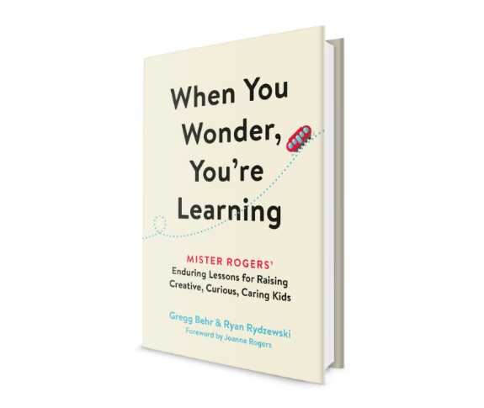Tuesday, June 15th at 8pm ET: PBS Books presents this Author Talk with Gregg Behr and Ryan Rydzewski discussing the important lessons we can continue to gleam from Mister Rogers’ Neighborhood. This special event will include an in-depth exploration of their book *When You Wonder, You’re Learning: Mister Rogers’ Enduring Lessons for Raising Creative, Curious, Caring Kids*, which traces indispensable “tools for learning.” As Behr and Rydzewski suggest, Rogers’ logic has only grown more applicable to education and parenting in modern contexts. The two authors will explore the explicit and implicit messages Rogers shared with us and how we might create productive visions for our future as we investigate them further.

**About the Book**

*When You Wonder, You’re Learning* is an essential exploration into the tools for learning that are still so vital in how we raise our children today. So much of what made Mister Rogers’ Neighborhood essential was invisible to the camera. Fred Rogers’ careful plans to nourish curiosity and encourage creativity were built so skillfully into his scripts and songs that viewers never even knew they were there. The lessons from Mister Rogers’ Neighborhood—and the designs that helped Rogers fulfill them—have never been more needed, especially in the wake of a deadly pandemic that changed the way children learn unlike anything else before it. According to data from the 2020 census, nearly 93 percent of households with school-age children reported engaging in some form of distance learning—a dramatic departure from how kids and families have typically learned in the past.

Featuring a foreword by Rogers’ late wife, Joanne Rogers, the book brings the lessons of Mister Rogers’ Neighborhood into the digital age. Each chapter reveals the logic behind Mister Rogers’ Neighborhood, connecting Rogers’ methods to the latest science and sharing helpful tips for parents and educators. Along the way, readers learn from renowned thinkers and scientists, many of whom worked with Rogers himself: media and communication experts, psychologists, museum curators, after-school program designers, and more.

**About the Authors**

* **Gregg Behr**, executive director of The Grable Foundation, is a father and children’s advocate whose work is inspired by the legacy of his hero, Fred Rogers. For more than a decade, he has helped lead Remake Learning—a network of educators, scientists, artists, and makers he founded in 2007—to international renown. Formed in Rogers’ real-life neighborhood of Pittsburgh, Remake Learning has turned heads everywhere from Forbes to the World Economic Forum for its efforts to ignite children’s curiosity, encourage creativity, and foster justice and belonging in schools, libraries, museums, and more. Behr is an advisor to the Brookings Institution and the Fred Rogers Center, and has been cited by Barack Obama and the Disruptor Foundation as an innovator and thought leader.
* **Ryan Rydzewski** is an education reporter whose award-winning stories on science, learning, and more appear in outlets around the country. A former elementary school teacher, his magazine features span everything from schools to space travel to Mister Rogers’ Neighborhood.